**Code Documentation and results discussion**

**Discrete convolution:**

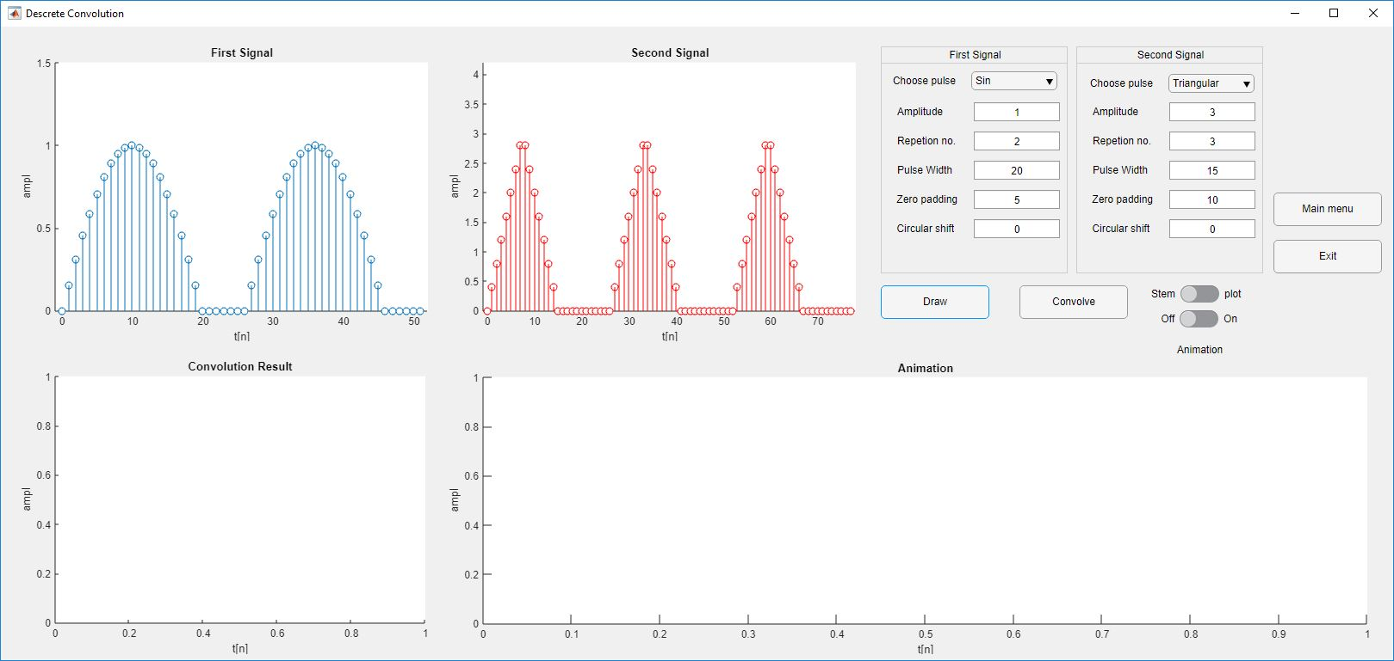

We will work in the example shown with the default parameters shown above.

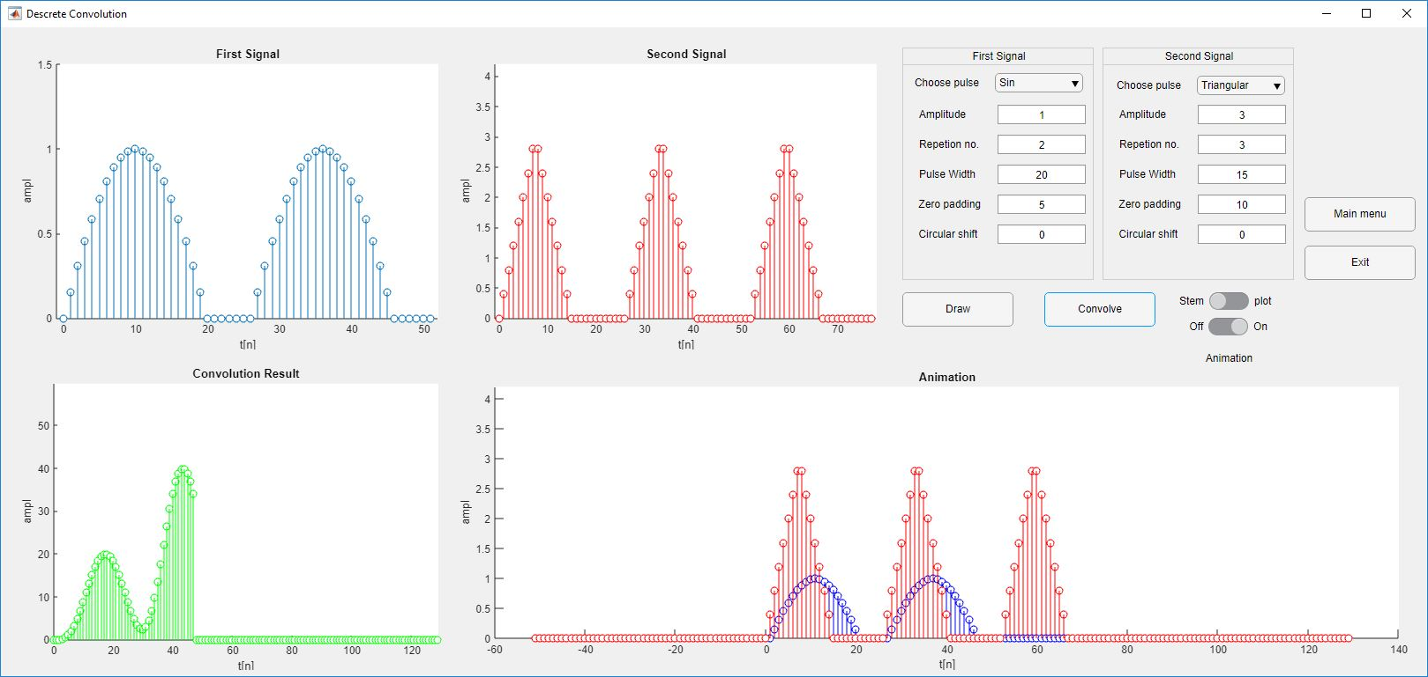

As seen above in the animation figure. When the intersection between the signal is maximum, the convolution amplitude is at its maximum. Because the result of the convolution is equal to the summation of the product of the common area. The equation as follows:

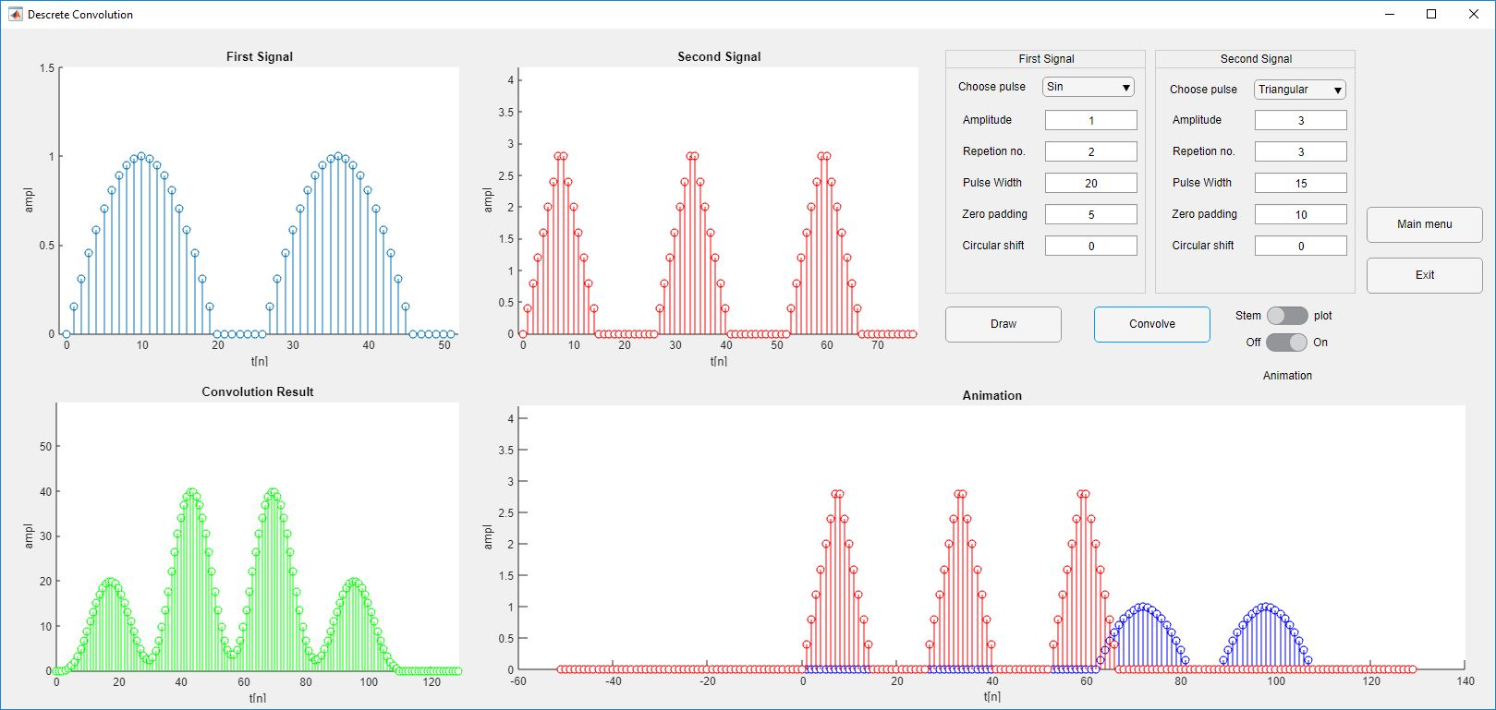Also it is noticed that when the area is at its minimum, the convolution is at its minimum.

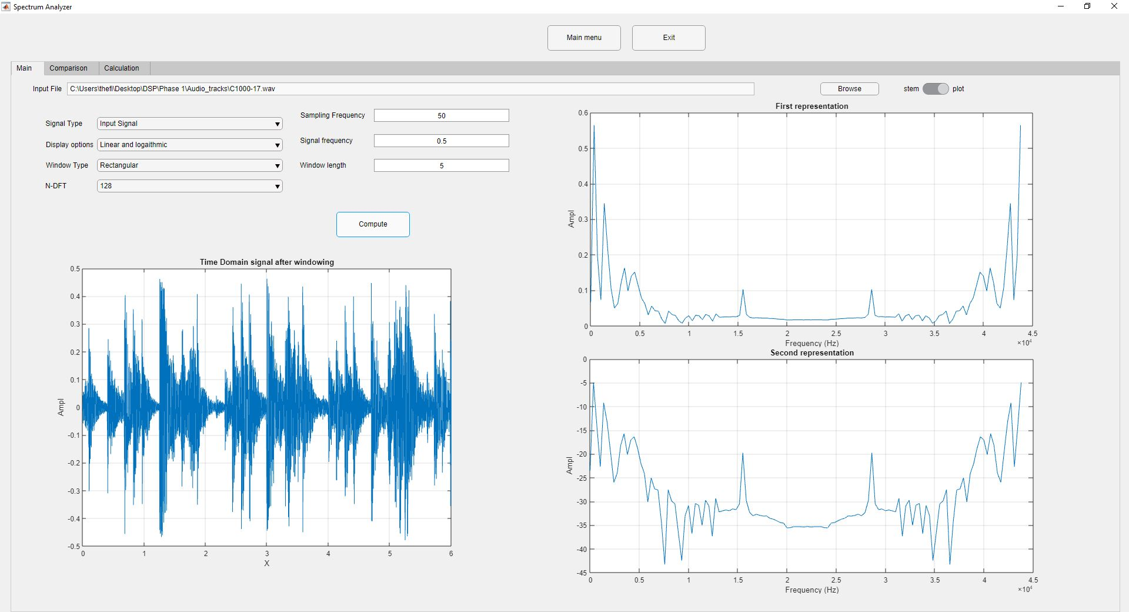**Main mode Spectrum analyzer:**

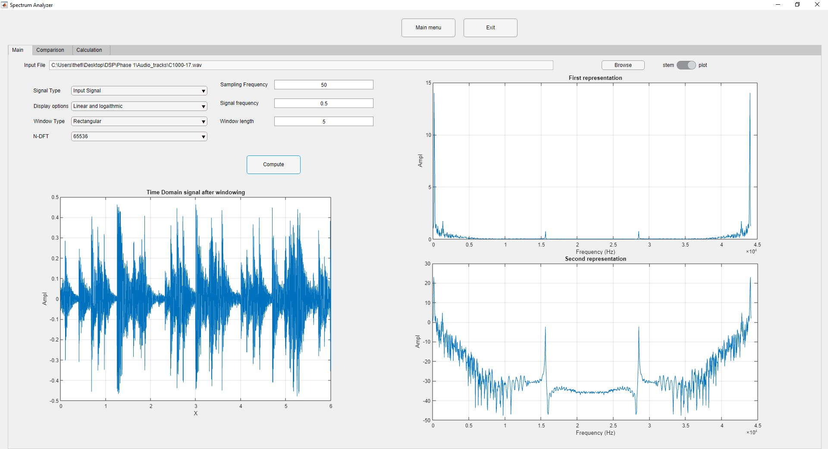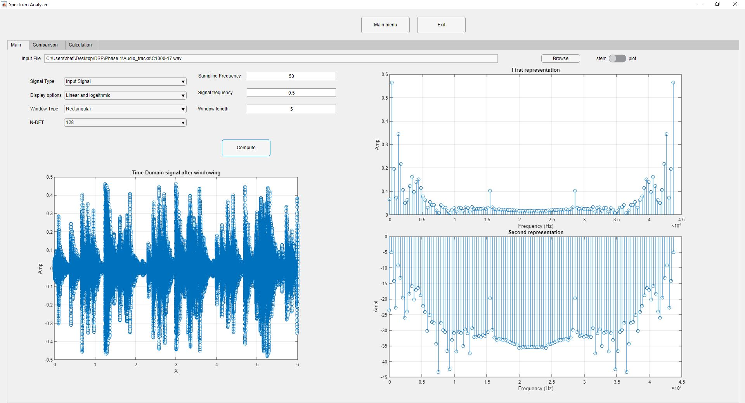I will use the continuous plot for readability.

**Results and conclusion:**

1. The results shown in the frequency spectrum corresponds to the magnitude of every frequency. It is observed that the peak of the frequency is at Hz .It is also observed that there are frequency at almost Hz .I believe that this is not due to noise
2. Also I hypothesize that the small magnitude frequency components are due to frequency leakage in the signal the rectangular window. Also there is a bad resolution due to the small n point DFT.
3. As seen from the figure below, the resolution has increased extremely due to the increase of the Order of FFT.
4. 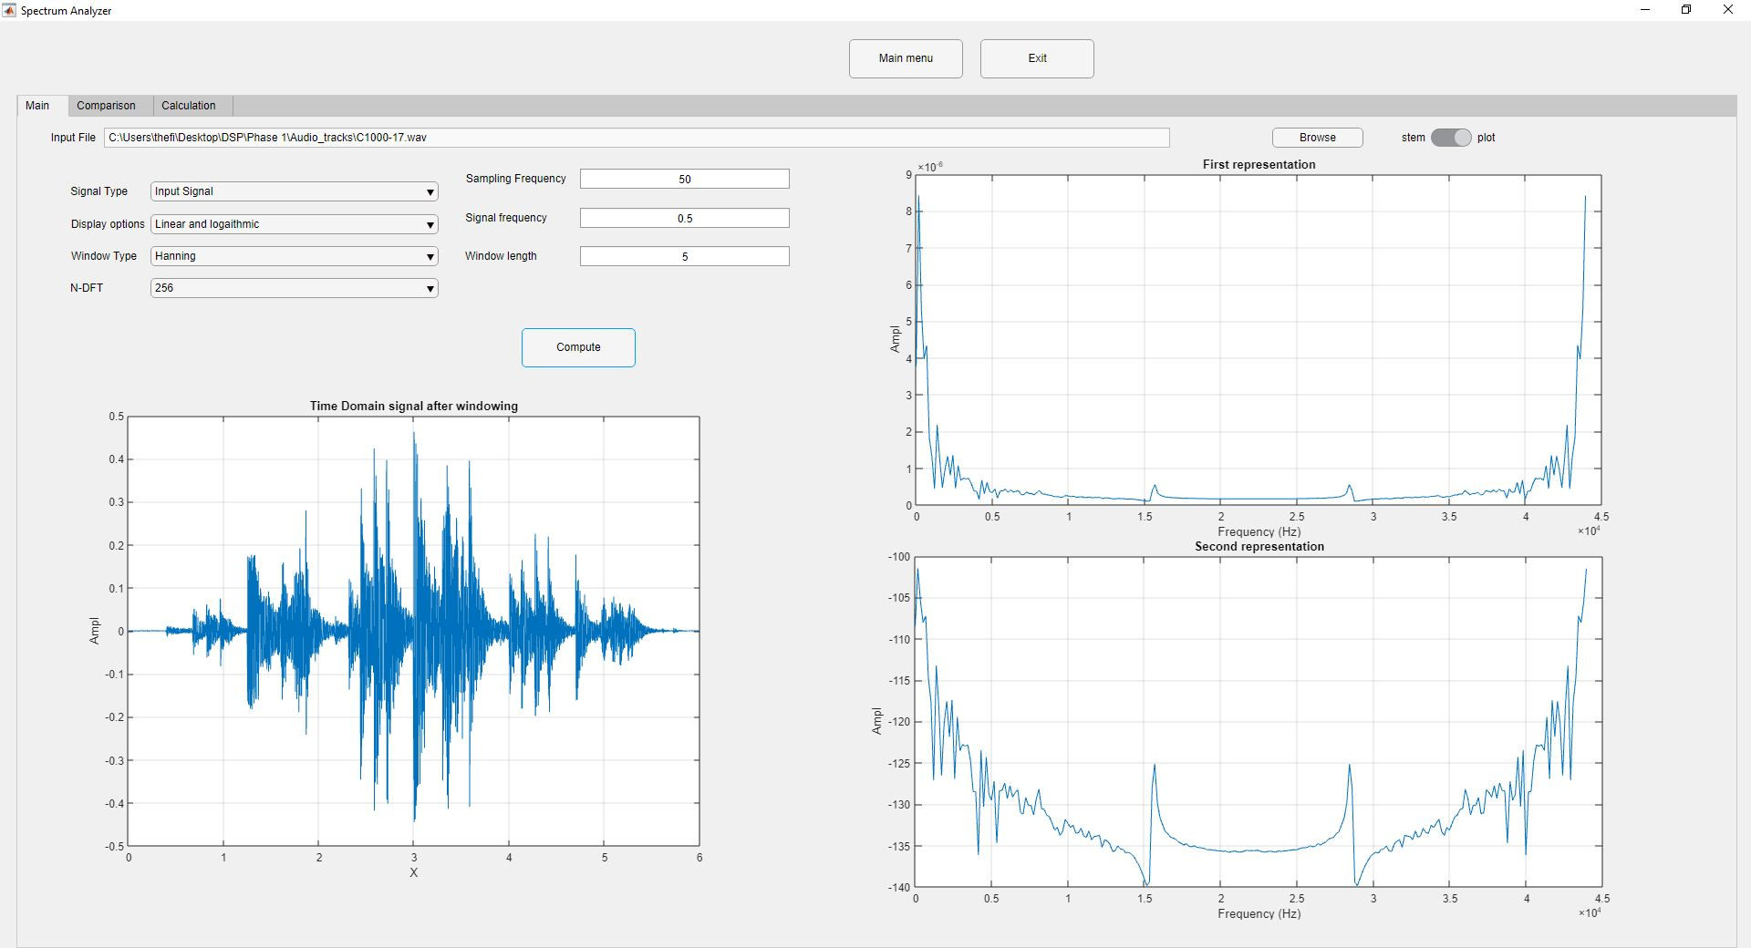As seen from the figure below. Compared to the first figure the leakage is much smaller. This is because we used the hanning window. As it has a smother decay instead of the rectangular window which has much sharper edge that maps to a sinc function with big side lobes that contributes the big magnitude of the leaked frequency bins. Also there exist a huge decrease in the magnitude of the frequency spectrum due to the scaling that the hanning window makes.

**Comparison mode Spectrum analyzer:**

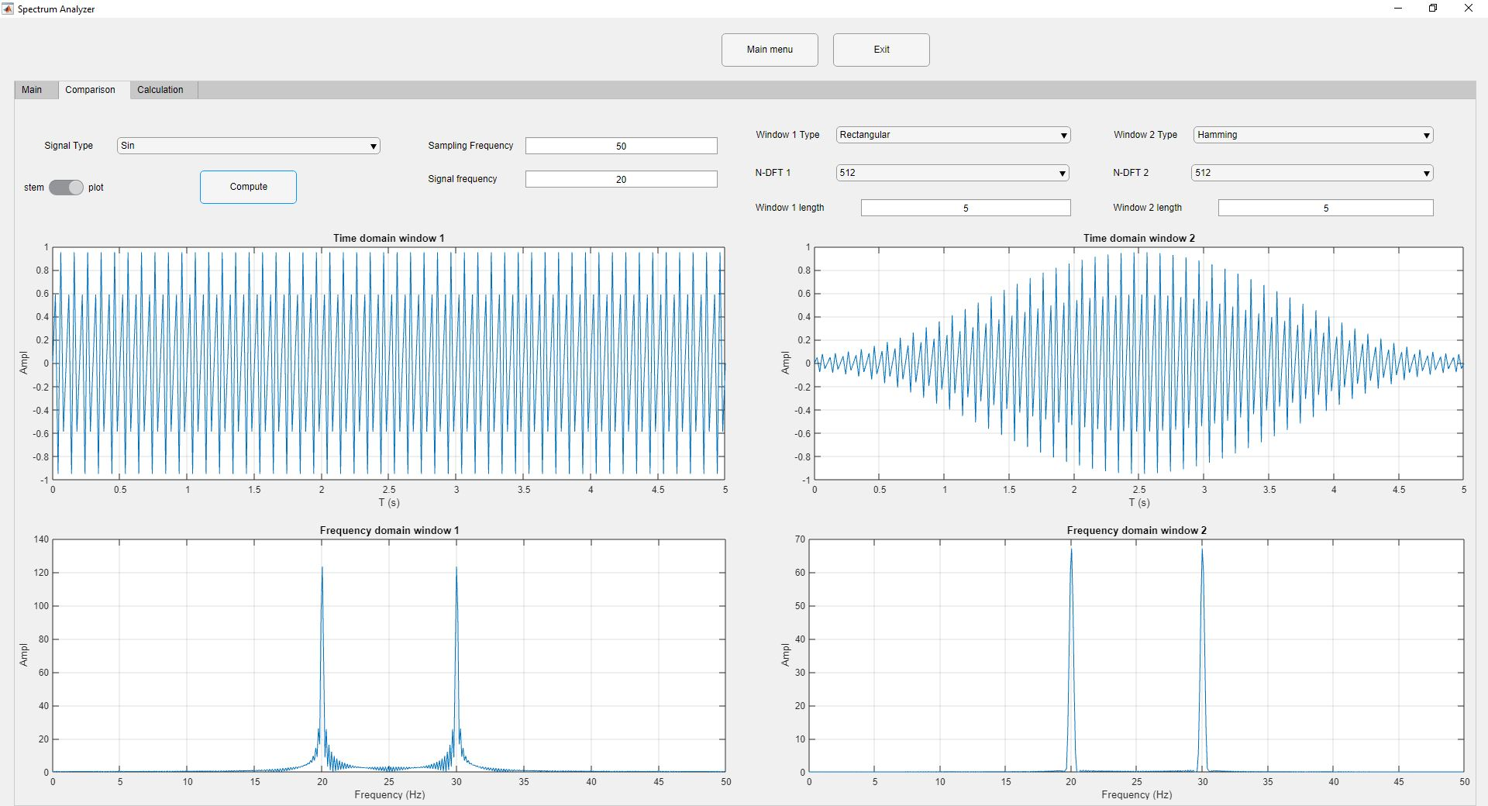

1. As observed from the example the 50 Hz frequency. there exists a leakage between the main frequencies when using the rectangular window in comparison to the hamming window. However, the magnitude of the frequency spectrum in case of the hamming has decreased, though the ratio between the signals almost holds in other words the resolution of the signal decreased in the expense of the decrease of the leakage. It also worth mentioning that the frequency is symmetric between Fs/2.

**Code Commenting and description**

1. I used app designer instead of guide due to the easy to design interface and because it has much properties that GUIDE.one of the main benefits, is that it contains a numeric data field that has resettable limits. and this made the error handling process much easier.
2. I have modulated the code into three main function types

* data acquisition .E.g:

function [F,Fs,widlen,widtype,NDFT,sigtype,input,display]= get_data(app);

* signal creation and drawing.E.g:

function [Fs,n,signal] = draw_windowed_signal(app)

* and last FFT and drawing

DFT_representation(app)

* convolution in the first window.

function convresult=drawconv(app)

1. Each one of the function takes app as an input and outputs what the next function needs to continue processing.
2. Almost the whole code Is well commented but it is worth mentioning the input file algorithm here.

* The input signal acquisition was a bit challenging because you will have to make sure that the user enters a valid path in order to save it in the variable. For example this code makes sure that the user has entered a valid path and if not it shows warning and drwas sin() signal instead.

if(input==' ')

signal=sin(2*pi*F.*n);

f = app.SpectrumAnalyzerUIFigure;

uialert(f,'File not found','Invalid File');

else

[signal , sample_rate]= audioread(input);

Fs=sample_rate;% we by default take the sample rate of the signal

duration=floor(length(signal)/Fs);

n=0:1/Fs:duration;

signal = (signal(1:length(n)))';

end

* Also if the user has pushed browse button and then decided to cancel the command, we return a space to the string in order not to put an invalid variable inside app.InputFileEditField.Value and return a space in order to activate the code mentioned above.

try %to handle the error if the user has canceld the browsing.and make sure that app.InputFileEditField.Value has a valid input

[file_name,path] = uigetfile({'*.wav'},'File Selector');

full_path= [path file_name];

app.InputFileEditField.Value=full_path;

catch

app.InputFileEditField.Value=' ';

end